Game Design Document

***Game: MamaChick***

***Team: MamaChick***

## Team Members

|  |  |  |  |
| --- | --- | --- | --- |
| **Name** | **Roles** | **E-mail** | **Photographs** |
| **Yueqin Li** | *Captain,*  *Physics* | *yueqinli@usc.edu* |  |
| **Meivenkatkumar Lakshminarayanan** | *Notetaker,*  *Physics* | *meivenka@usc.edu* |  |
| **Zhenyu Liang** | *System,*  *Analytic* | *zliang58@usc.edu* |  |
| **Nithesh Reddy Kothapally** | *Design, Guidance,*  *User Interface* | *nitheshr@usc.edu* |  |
| **Haoxiang Geng** | *Guidance,*  *User Interface* | *gengh@usc.edu* |  |
| **Jiachen Wang** | *Product Manager, Analytic* | *jwang000@usc.edu* |  |

## Important References

|  |  |
| --- | --- |
| Engine | *Unity* |
| GitHub | [*https://github.com/pppiyo/MamaChick*](https://github.com/pppiyo/MamaChick) |
| Playable Alpha Build | [*https://meivenka.github.io/mamaChickDeployment/*](https://meivenka.github.io/mamaChickDeployment/) |
| Playable Beta Build |  |
| Playable Gold Build |  |

# Game Introduction

## Logline

Our game is an Angry Birds-like Strategy shooter game with black jack as a twist. Instead of focusing on destruction, we focus on strategizing resource (Time and Feed) distribution.

PS: Players could easily improve their time management, calculation speed and hand eye-coordination.

**Basic Control:**

Left / Right Arrow: Move Shooter left and right

Space: Pick up stones or feed1

Mouse Click & Drag: Aiming

Mouse Release: Throw

## Goal

*Successfully shoot a certain number of Feed2 on the target.*

*Defend boxes from the flying enemies*

*Clear all levels*

## General Description

"Mama Chick" is a game prototype that combines strategy shooter mechanics with the poker game, Blackjack. Here the player as shooter needs to fill the hands(yellow buckets) on the other side of a fence using feed2 and feed1 whilst defending them from enemies flying overhead by throwing stones. In this five minutes’ game, the player’s objective is to keep hands alive and grow each Hand's magic power to exactly 21.

The game has two metrics for each Hands: Health Points (HP) and Magic Points (MP). HP will reduce from 100 to 0 within 2.5 minutes. When it becomes 0, the Hand will disappear. MP, is gained through feed2: there are exactly 13 feed2 on the tree, for a deck. Shooter will hit feed2 with stones in order to send them to the hands. Hands which get fed this way will get magic values corresponding to the feed2 they are being striked with. Once a hand gets overfed, the Hand will also disappear. Once MP reaches 21, Total Score rises by 1. To gain maximum points, the player needs to get as many chick’s MP to 21 as possible while keeping them alive. By the end of this game, the player’s score will be calculated based on the number of chicks they successfully raised up.

# Detailed Design

## Sketch/Diagram:

**Prefab Assets and Overall Layout:**

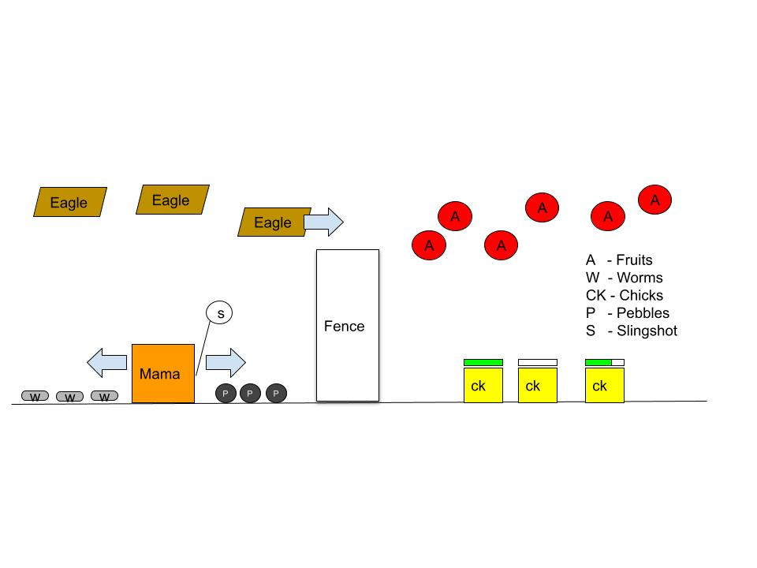

**Projectile Action:**

General Projectile action for any rigidBody

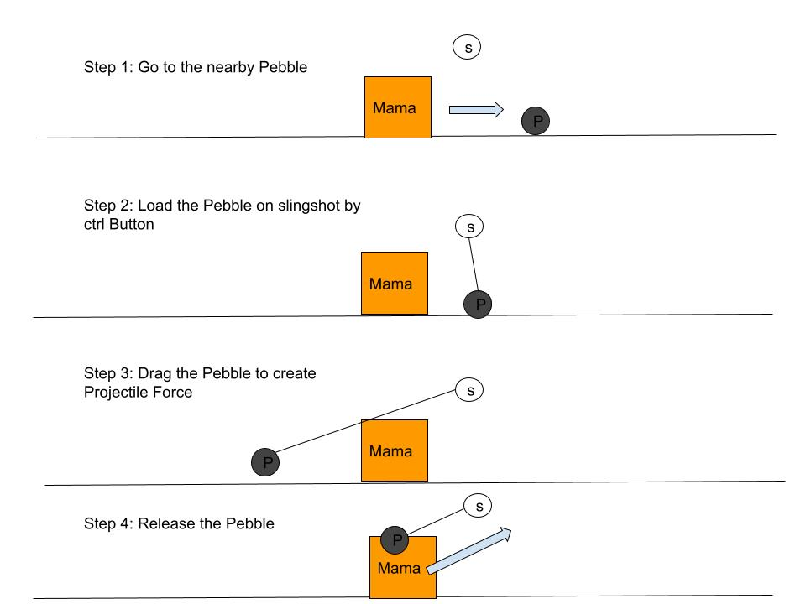

**Feeding Fruit:**

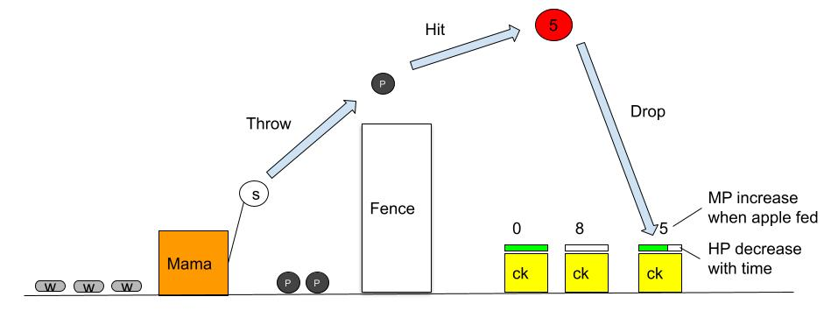

**Special Treat:**

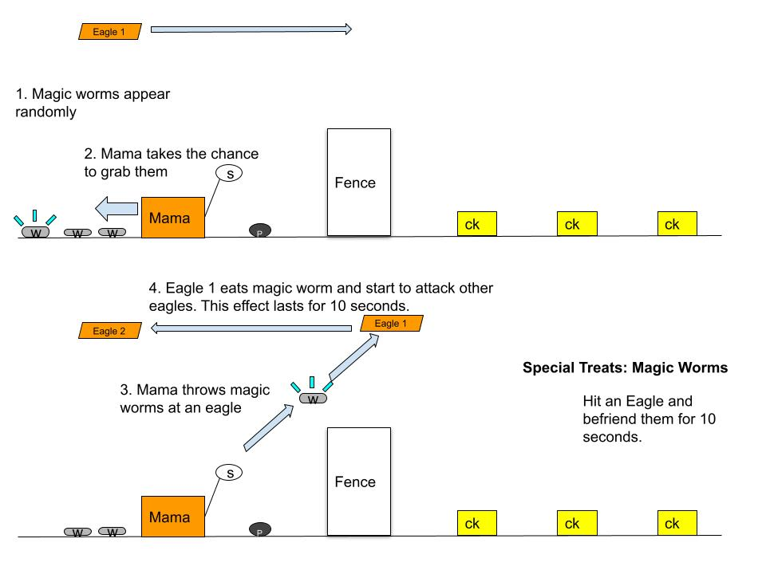

**Projectile at Eagles:**

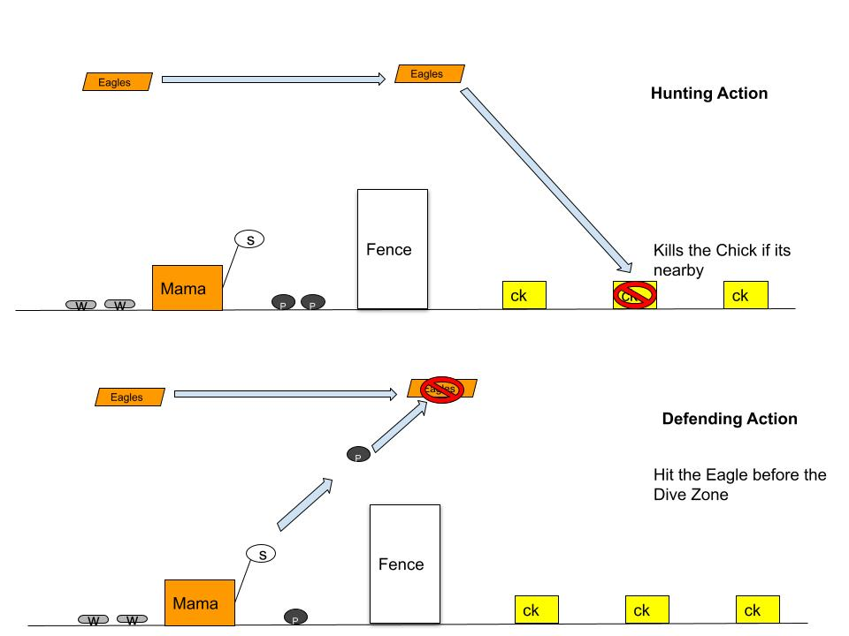

## Game Element

*1. Shooter with a slingshot*

*2. Feed1 - increases HP of each hands*

*3. Feed2 - increases MP of each hands*

*4. Stones - used to knock off flying enemies or Feed2*

*5. Hands/Bucket - They are aimed at collecting 21 MP each.*

## Game Mechanics (How to Play)

*Movement mechanic: Use left-right arrows or A-D to move the shooter*

*Projectile mechanic: Use mouse click and Drag to aim projectile objects.*

*Score mechanic: reaching 21MP on each Hand gives the player a game point.*

*Collision mechanic: Stone-Feed2 simulates perfect collision.*

## Gameplay Loop

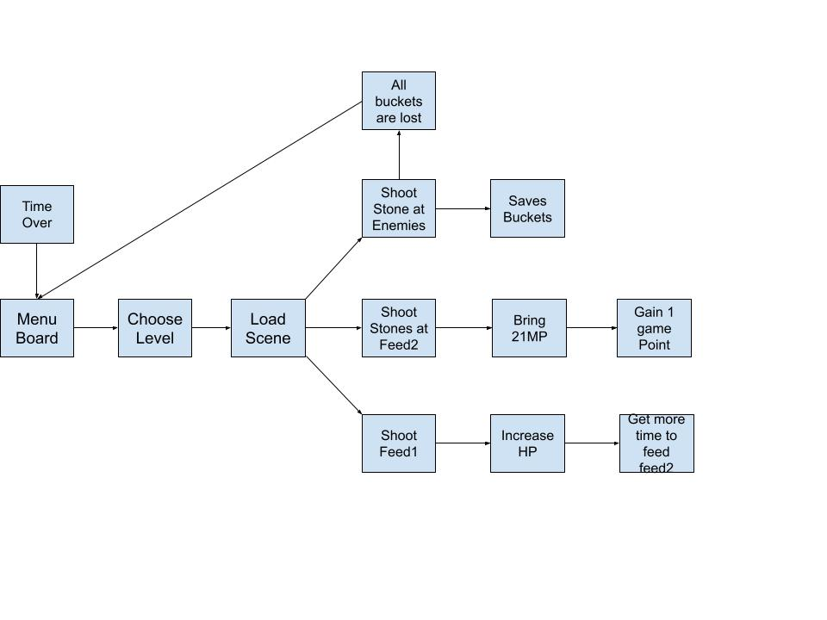

# Weekly Prototype Descriptions

Week 7:

* Tutorial Mode - Gameplay Design
* Checking different Analytics resources.
* Prototyping different projectile methods
* Different game level designs
* Sample design:

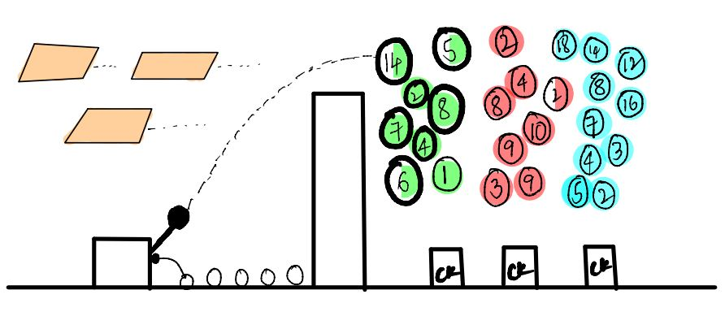

Week 8:

* Game Menu Board
* Tutorial Mode
* Firebase Data analytics metric 1
* Projectile path/aim guiding system improved

Week 9:

* Create a new 2D version to refine graphics and the aiming system.
* Create a succinct tutorial and enlarge the buttons
* Create a button to get out of the tutorial mode
* Use Space to pick up things instead of ctrl
* Add introductions of game objects at the beginning of the tutorial
* Redesign projectile module

# Analytics

Methodology Used: We rely on RESTClient to send player data to Firebase Real-time Database when the game ends each time. On the analysis side, we retrieve data from the database by sending requests and conduct real-time analysis using Jupyter and matplotlib. Through data visualization, we refine our level design and all the details.

## Analytics - Mockups/Results

**Metric #1: Game success status and time left (Implemented)**

**Description**: Record the game success status and time left when users finish a specific level.

**Initial Sketches: (Image)**

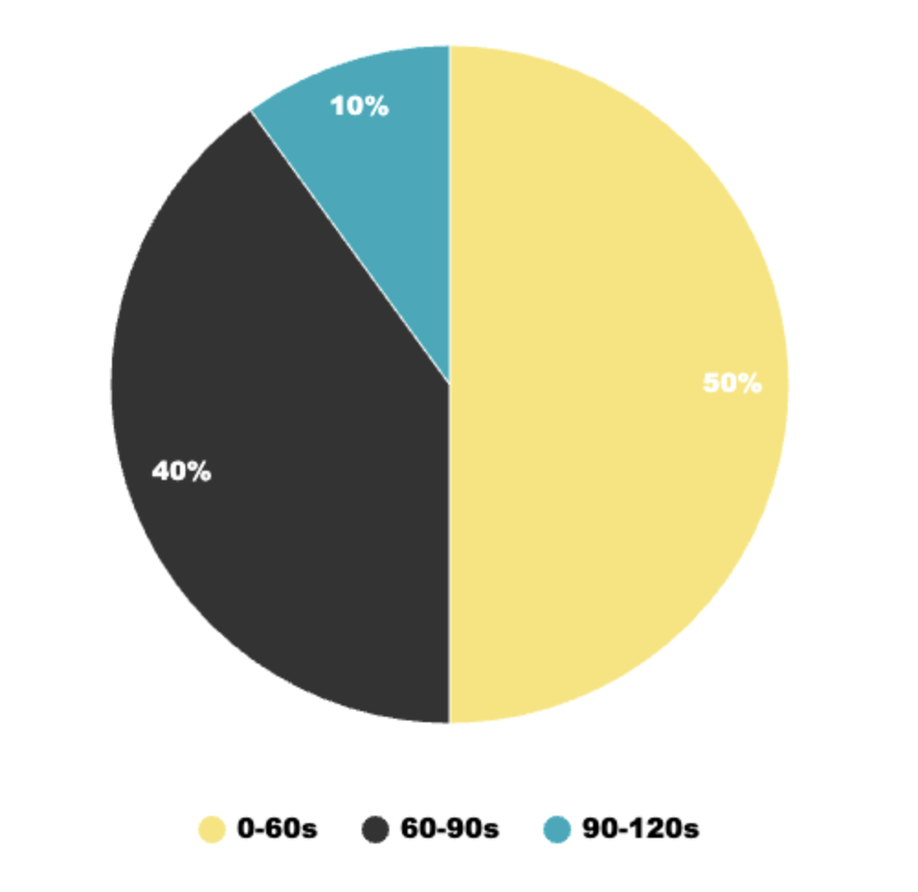

**Expected results**: Users are able to achieve each level within reasonable time. In our first level, we should reduce the difficulty. Therefore, users should be able to achieve this level in a relatively short time. If it takes longer, the reasons could be that the tutorial didn't provide sufficient guidance for users, or the apples arrangement needs adjustment. We should then adjust them. Fortunately, most users completed level 1 within 90 seconds.

**Metric #2: Chicks left (mockup)**

**Description**: Record the number of chicks left in each level when the level ends. If the percentage of no chick left is too high, we should consider reducing the rate of hp decline. If the percentage of all chicks left is too high, we should consider if this level is too easy.

**Initial Sketches: (Image)**

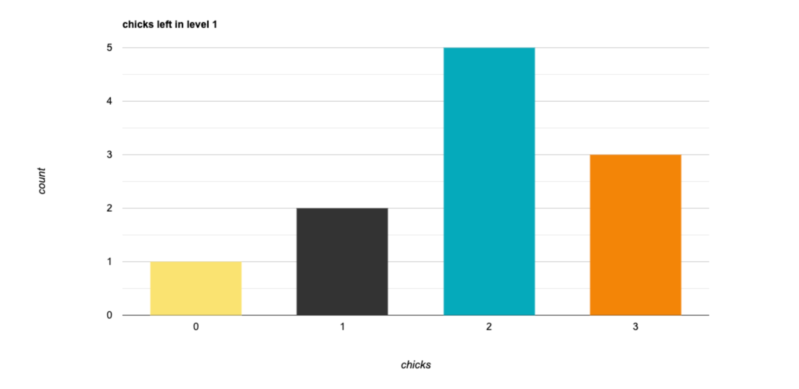

**Metric #3: User thrown hit rate (mockup)**

**Description**: Users will use our projectile to throw objects. We record the number of throws by users and the number of times a thrown object hits a valid object. If the hit rate is too low, we should refine our projectile to enhance the user's gaming experience.

**Initial Sketches: (Image)**

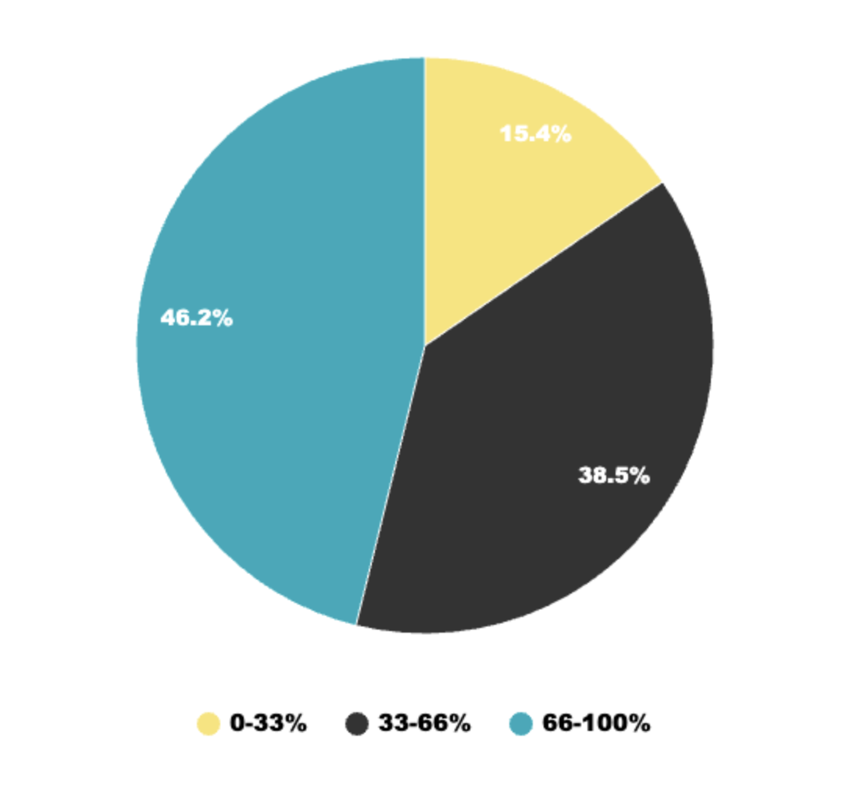

**Metric #4: Chicks attacked by eagles in each level (mockup)**

**Description**: In specific levels, we randomly spawn eagles that may attack our chicks. So we record the number of chicks attacked by eagles at each level. If the percentage of the number of chicks attacked by eagles is too high, we should consider reducing our game difficulty accordingly.

**Initial Sketches: (Image)**

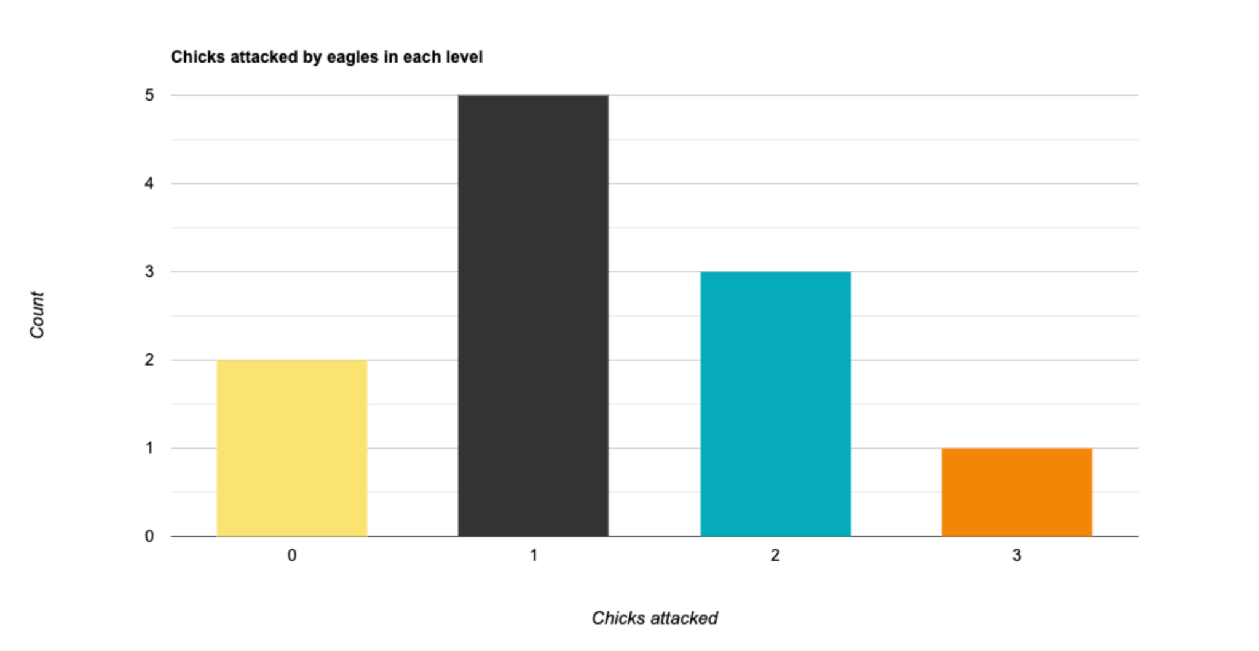

# Review Notes

**10/10 Review Notes from grader**

Issue1 - Aiming system was not helpful.

Solution: working on improving aiming system

Issue 2 - Too slow and bad graphics.

Solution: Working on a 2D version that refines graphics and pace

Issue 3 - Difficult to understand overall game mechanics.

Solution: Refined tutorial.

**10/10 Review from professor’s pod testing (Note taker: Yueqin Li)**

Issue 1 - Tiny button in tutorial

Issue 2 - Tutorial Too long (3 sentences will be the threshold). Not until Page 5 does the player realize what’s going to happen

Issue 3 - Don’t know how to get out of tutorial

Issue 4 - Doesn’t know how to pick up things (space bar used first)

Issue 5 - What are apples? What are magic points?

Issue 6 - Projectile?

Potential Solution

Solution for Issue 1 - enlarge button

Solution for Issue 2 - Shorten the sentences in tutorials, minimize number of text

Solution for Issue 3 - add a return button in the tutorial

Solution for Issue 4 - change pickup trigger to space bar

Solution for Issue 5 - add introductions of game objects at the beginning of the tutorial

Solution for Issue 6 - debug/revise/redesign projectile module

10/17

**(Note taker: Yueqin Li)**

Do people understand how to play?

Arc: grab things and put into the box, give guides

Get this in front of new eyes that do not know what to do.

Confusion about updating score?

First time user experience.

Everybody should be a note taker

Improvement on mechanics

**(Note taker: Mei)**

[17/10, 16:42] Mei: Yellow and small - tough to read Surprised if anybody else knows how to play

[17/10, 16:43] Mei: - going in a direction.of authors - not focused on new player's perspective

[17/10, 16:44] Mei: Gregious - describe direction of throwing apple into the chick - arrow mark.

[17/10, 16:45] Mei: Validation of score - after every hit, makes it visible.

[17/10, 16:45] Mei: Nee eyes, make them play. Still memory game, figure it out game.

[17/10, 16:45] Mei: Get more first time experience

Poen: think about more mechanics - give more dimensions. Don't stick with the current mechanics alone

# Weekly Homework

|  |  |  |
| --- | --- | --- |
| **Week Number** | **Team Member** | |
| **Week 8** | **Yueqin Li** | **Meivenkatkumar Lakshminarayanan** |
| Data Analytics | projectile refine |
| **Zhenyu Liang** | **Haoxiang Geng** |
| UI and tutorial | tutorial design |
| **Nithesh Reddy Kothapally** | **Jiachen Wang** |
| scene transitions | Game feel/redesign, data analysis |
| **Week 9** | **Yueqin Li** | **Meivenkatkumar Lakshminarayanan** |
| 2D refactor, GDD | Projectile revision |
| **Zhenyu Liang** | **Haoxiang Geng** |
| Data analytics | Tutorial revision |
| **Nithesh Reddy Kothapally** | **Jiachen Wang** |
| UI and Scene transitions | 2D refactor, GDD |
| **Week 10** | **Yueqin Li** | **Meivenkatkumar Lakshminarayanan** |
| 2D refactor,  Level Design and implementation | 2D Projectile revision |
| **Zhenyu Liang** | **Haoxiang Geng** |
| Game Logic, Data analytics | GDD game introduction |
| **Nithesh Reddy Kothapally** | **Jiachen Wang** |
| Level Design and implementation | 2D refactor,  Level Design and implementation |